Expunctions
The following is a list of agencies normally involved in the expunction process. The petition should include both the physical or mailing address as well as the e-mail address for each agency. This list is not all-inclusive. Any outside agency that has available or published information concerning the charge or arrest should be included. There is a $25 fee for each agency included in the petition that does not have an email address to cover the expense of certified mail to transmit application with notice and final order. Duplicate agencies will not be notified. DO NOT include agencies in your petition who do not have records related to the case. The initial filing fee is $350.00.
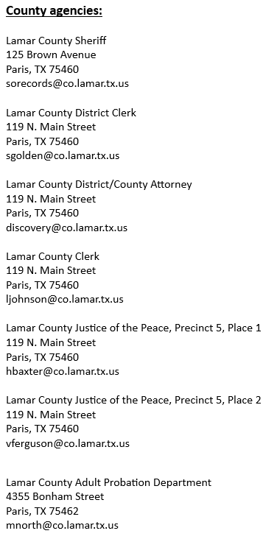

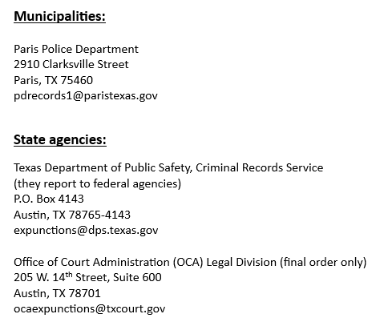
An expunction order obliterates an arrest from the person’s criminal history and all files associated with the arrest and charge. There are certain conditions that must be met to be eligible for an expunction. The District Clerk’s Office cannot provide legal advice nor provide forms for filing an expunction. For this information and more, you are encouraged to consult with an attorney. If you cannot afford an attorney, please visit www.texaslawhelp.org for guidance and forms.

This list is required to be published and maintained by the district clerk of the county pursuant to Senate Bill 1667, passed during the 89th legislative session, effective 9/1/2025.

